

**BY**

**Y.LOKKESHWAR (2018506057)**

**V.MADHUSUDHAN (2018506059)**

**M.SRIHARI BALAJI (2018506123)**

**DESCRIPTION:**

This project is created on the basis of reserving seats on an airline using an easy gateway portal. We have implemented the ticket booking for an airline in a step by step process, which we briefly describe below as separate modules. We begin as usual by a Login process followed by displaying flights on both Domestic and International terminals allowing the user to select any one based on his requirement. We have also added an option for both Economic and Business classes. Finally, proceeding to attaining a receipt of the ticket. We have used Java Swings to get the input from the user and the results are returned through queries in DB in the background .

**MODULES:-**

**LOGIN PAGE:**

As the process begins, this is a usual routine for accessing any website and the same follows here also . The user can proceed to booking tickets only on passing through the login page. The login details of a particular user are stored on the backend in the form of a DB by the admin. On completing this process, the user can then proceed to the next activity he has to do in order to book a seat in a flight.

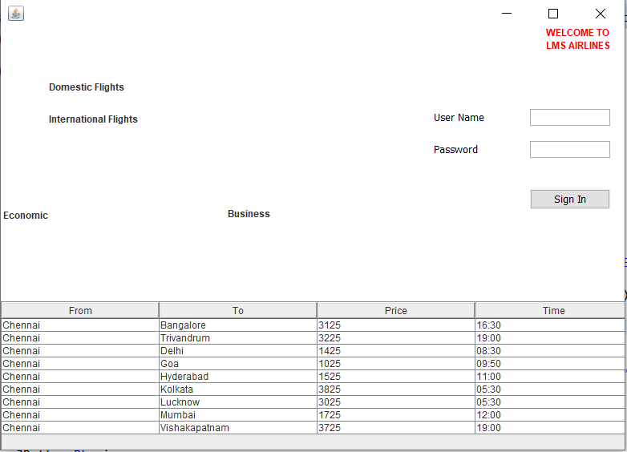

Login:

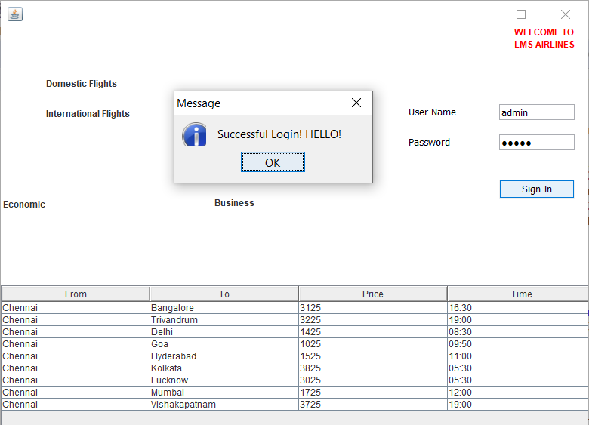

Login (Test Case):

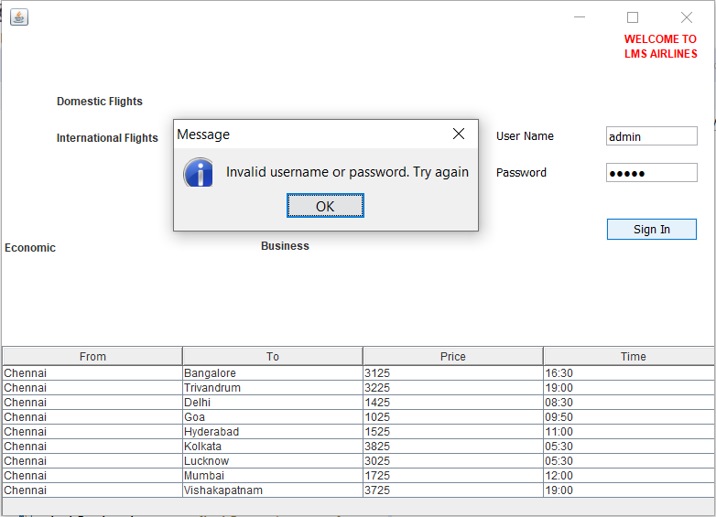

**DOMESTIC FLIGHTS:**

In this module, we display the available flights in the domestic terminal. And of course, all these flight dates, timings, availability are all maintained in the DB and also these flight details are available to be viewed by the user. The user can then decide on which flight he wants to board based on his needs and requirements.

**Domestic Economic Class Flights:**

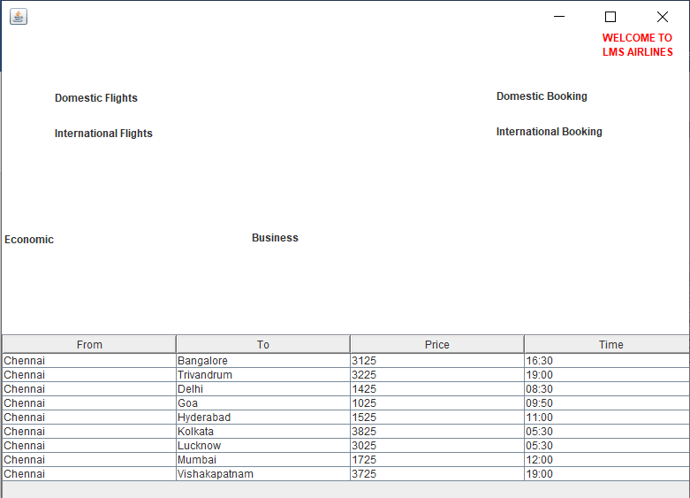

**Domestic Business Class Flights:**

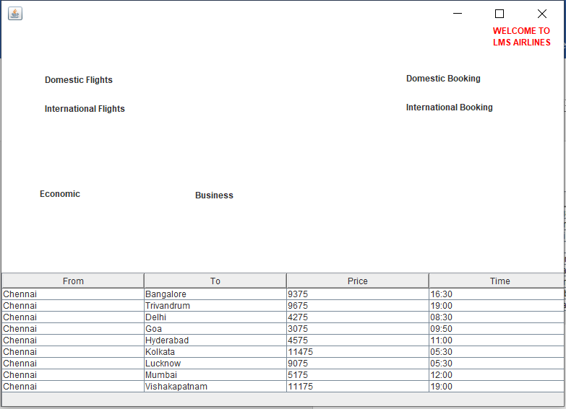

**INTERNATIONAL FLIGHTS:**

In this module, we display the available flights in the international terminal. And of course, all these flight dates, timings, availability are all maintained in the DB and also these flight details are available to be viewed by the user. The user can then decide on which flight he wants to board based on his needs and requirements. We have implemented the same viewing feature for both these terminals.

Also, we have implemented a feature in this project which displays flights in the criterion of economic or business classes.

**International Economic Class Flights:**

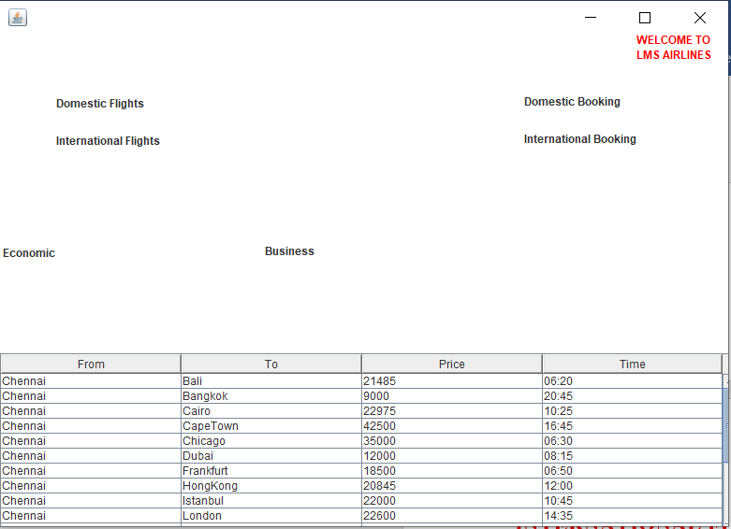

**International Business Class Flights:**

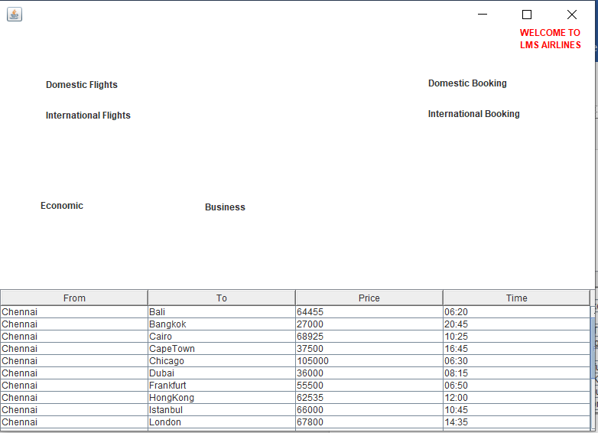

**FLIGHT BOOKING:**

We have designed a system in which the user requests for the type of flight journey, domestic or international, and then user’s source and destination addresses, the date and time of the journey, the no. of people boarding, are they adults or children, and depending on all the requirements provided by the user, he/she is given a message if seats are available or not, and if available can the process be proceeded to billing of the receipt.

**Domestic Flights Booking:**

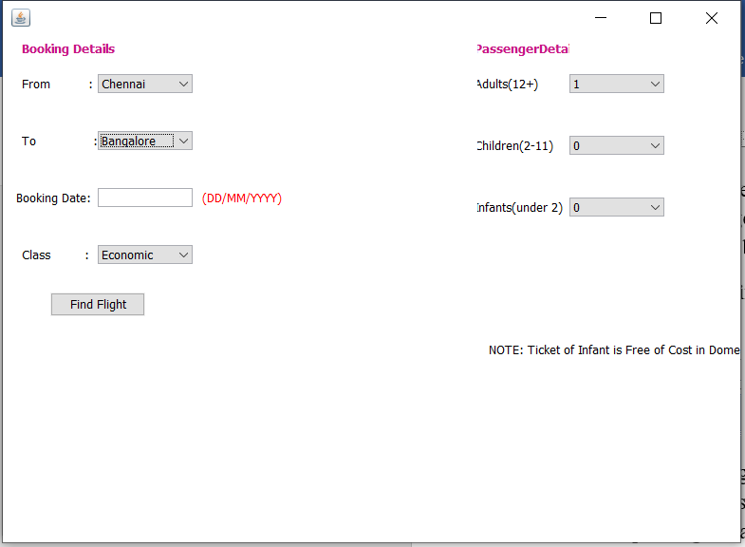

**International Flight Booking:**

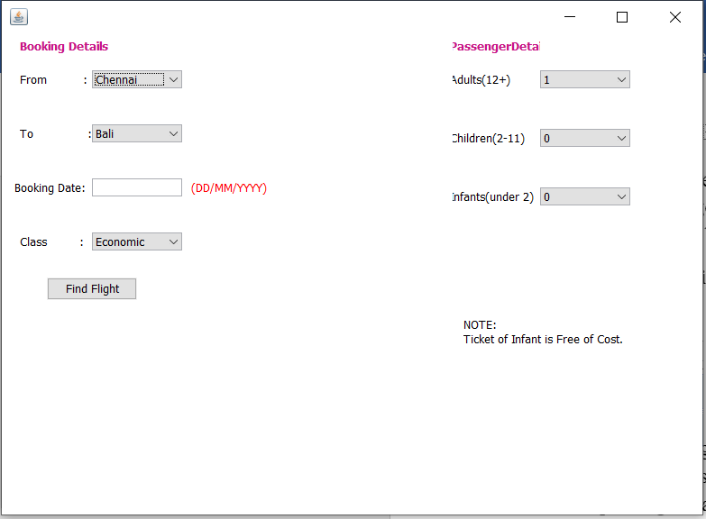

**Booking ( Test Case ):**

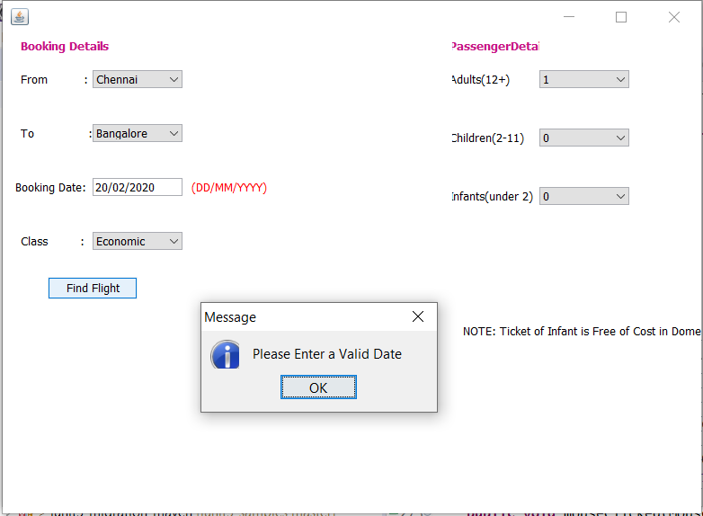

**PRINT TICKET:**

On updating all the information needed to board a flight, the user is displayed a receipt of his ticket, mentioning all his requirements, including date, time, no. of passengers, and especially the total bill amount to be paid. All these activities are maintained in the backend in the form of a DataBase.

**Domestic Flight Ticket:**

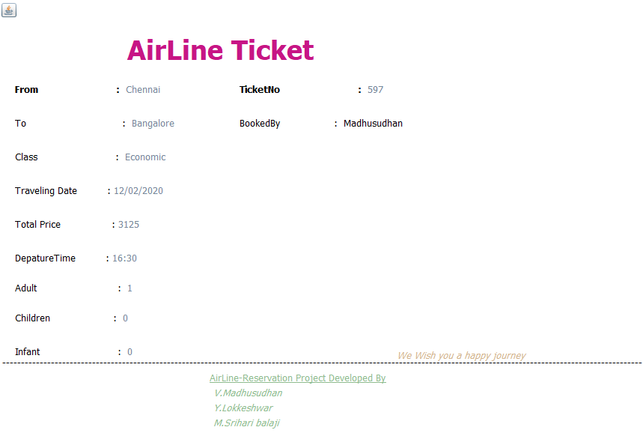

**International Flight Ticket:**

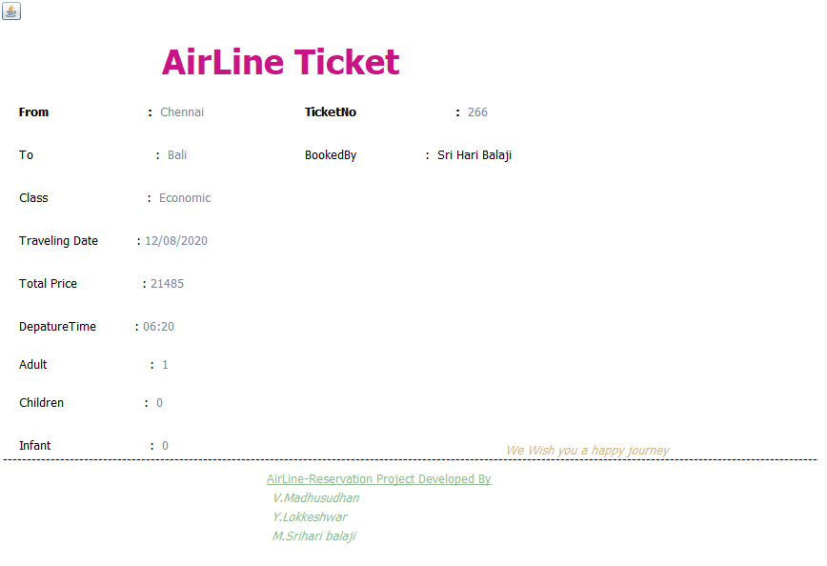



**Database:**

The Corresponding Booked Details are Store in the Ticket table of our

Airline Database of MySql Database using Java Database Connectivity.

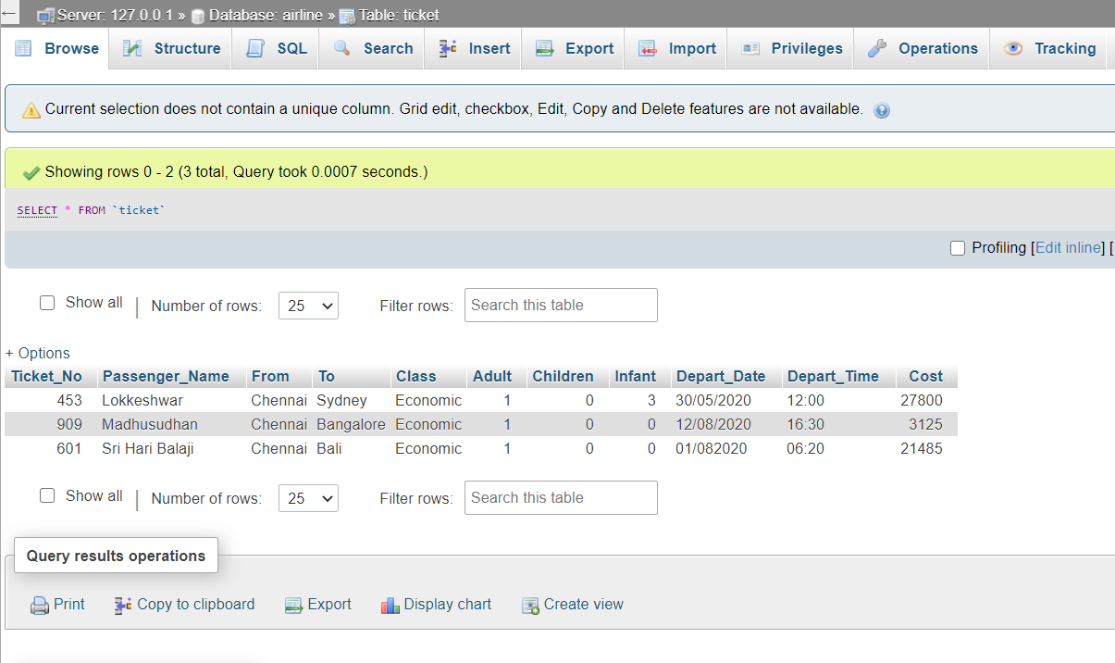

**CONCLUSION:**

Thus, through our project, we hope that the airline reservation is made in an easy, customer-friendly and a comfortable manner.

